Assignment 15
Inter-VLAN Routing Concepts

Shreya Panchal
Topic: Why is Inter-VLAN Routing Needed? Router-on-a-Stick (RoS) Configuration

Theory Overview

1. Why is Inter-VLAN Routing Needed?
By default, Virtual Local Area Networks (VLANs) segment a physical local area network into separate logical broadcast domains to improve security, reduce broadcast storms, and organize network management. Because each VLAN forms an isolated broadcast environment, devices inside one VLAN cannot communicate with hosts in another VLAN at Layer 2. To pass data between different subnets, a Layer 3 routing engine (such as a router or a Layer 3 switch) must route traffic between them.

2. Router-on-a-Stick (RoS) Method
Router-on-a-Stick is a traditional inter-VLAN routing method where a single physical interface on a router connects to a Layer 2 switch over a single physical link. This link operates as a trunk port. The router's physical interface is divided into multiple logical virtual interfaces called sub-interfaces. Each sub-interface handles its own dot1Q encapsulation tagging and serves as the default gateway for its assigned VLAN.

Tasks & Answers

Task 1: Create VLANs and Assign Ports on a Single Switch
Question: On a Cisco Packet Tracer or GNS3 simulation, create three VLANs named Insta, Zomato, and Flipkart on a single switch, and assign at least one PC to each VLAN.
Answer:

Network Assignment Matrix
VLAN | Name | Subnet | Assigned Interface
10 | Insta | 192.168.10.0/24 | FastEthernet0/1
20 | Zomato | 192.168.20.0/24 | FastEthernet0/2
30 | Flipkart | 192.168.30.0/24 | FastEthernet0/3

Switch Configuration Commands
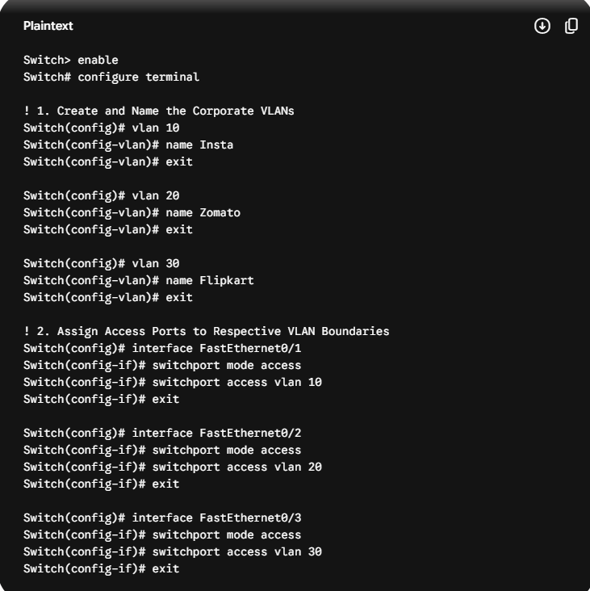

Task 2: Configure Router-on-a-Stick Sub-interfaces
Question: Configure a Router-on-a-Stick setup by creating sub-interfaces (e.g., GigabitEthernet0/0.10, .20, .30) on a simulated router, each with an IP address for the corresponding VLANs Insta, Zomato, and Flipkart.
Answer:

Router Configuration Commands
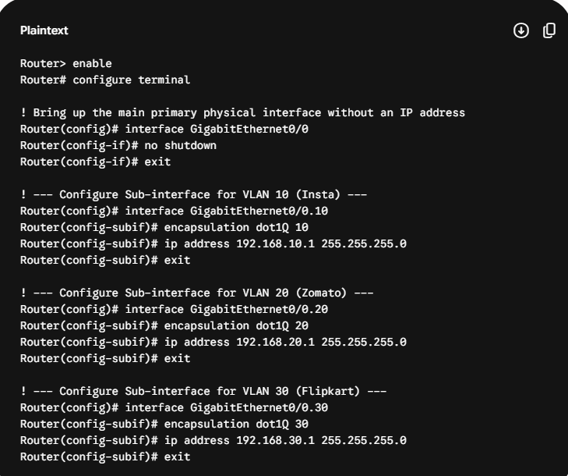

Task 3: Configure Switch Trunk Port Link and Verification
Question: Assign the switch port connected to the router as a trunk port, and verify trunking is active using the show interfaces trunk command. Hint: Use the switchport mode trunk command on the relevant interface.
Answer: Assuming the switch interface connecting to the router's physical interface is GigabitEthernet0/1.

Switch Configuration Commands
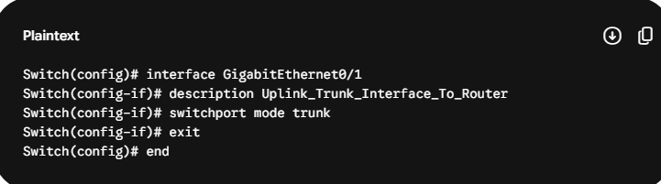

Verification Execution Command
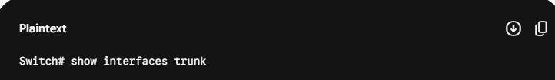

Expected Console Status Output
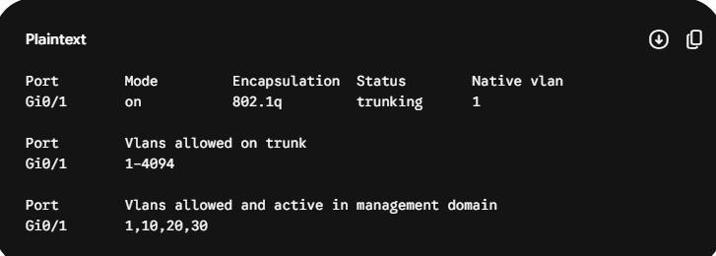
The verification logs confirm that interface Gi0/1 is actively tracking traffic using the dot1q standard for VLANs 10, 20, and 30.

Task 4: Test Inter-VLAN Connectivity and Flow Analysis
Question: Test inter-VLAN connectivity by pinging from a PC in the Insta VLAN to a PC in the Zomato VLAN, and explain why the ping succeeds or fails based on your configuration.
Answer:
- Open the Desktop Command Prompt on the PC in the Insta VLAN (192.168.10.10).
- Run the connection testing target script: ping 192.168.20.10.
Observation Outcome: The target returns a valid response string showing Reply from 192.168.20.10.

Technical Flow Explanation
The ping succeeds because the network has a functional Layer 3 routing gateway interface configured on the router.
When the Insta PC sends a packet to the Zomato PC, it recognizes that the destination IP (192.168.20.10) resides on a different subnet. The host encapsulates the frame and forwards it up to its configured default gateway interface (192.168.10.1). The switch receives this frame on port Fa0/1 and forwards it out the trunk port Gi0/1 with an 802.1Q tag identifying it as VLAN 10.
The router receives the tagged frame on sub-interface Gi0/0.10, reads the routing table, and determines the path out through sub-interface Gi0/0.20. The router then re-tags the frame for VLAN 20 and forwards it back down the trunk link. The switch receives the frame, strips the VLAN 20 tag, and delivers it to the destination PC on port Fa0/2.

Task 5: Live Expansion and Refactoring (Adding Spotify VLAN)
Question: Refactor your Router-on-a-Stick configuration to add a new VLAN called 'Spotify' without disrupting existing VLAN communication, and document the exact commands you used for both the switch and the router.
Answer: To expand the topology without causing network downtime or disrupting existing traffic on VLANs 10, 20, and 30, we append the configuration properties onto both operational units.

1. Configuration Updates on the Switch
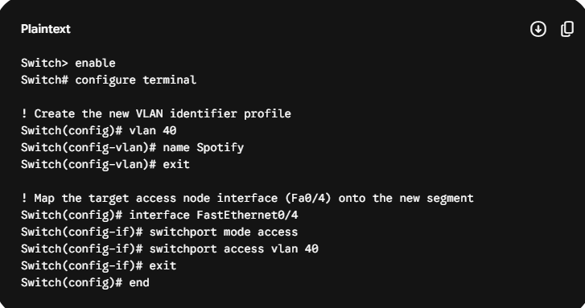

2. Configuration Updates on the Router
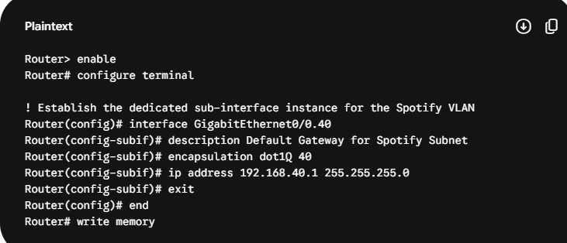
Verification: The newly added host in VLAN 40 immediately gains access to route traffic across the network, while the existing communication paths for the Insta, Zomato, and Flipkart VLANs continue running without disruption.

